Tony Scherm Barbeque Dip
I use this dip when barbequing on a grill, cooking in a skillet, or baking in the oven. It's a great dip (sauce) for either chicken or pork.
NO HATING ON THE FRACTIONS USED. IN SOME CASES I’M USING CUPS AS THE DENOMINATOR. A CUP IS 8 OZ.
IF IT’S EASIER FOR YOU TO REDUCE THE FRACTIONS, WHO AM I TO STAND IN YOUR WAY?
This is just how I do it. Everybody has their own way of doing stuff. If you don’t like my way, then do it your way. It none of my business.
SIDE NOTE.
If you like this dip, make more than you'll need and put the extra into a clean Mason-type jar with a lid. This stuff will keep for months in the refrigerator because of the vinegar. That way you can have it when you don't have time to make it from scratch. We also can it. I'll make enough for 20-24 chickens and the excellent half cans it. We have used it for as long as 18 to 24 months after canning just sitting in the pantry. Refrigerate after opening.
RECOMMENDATION.
Make more than you think you'll need. If you're making 2 chickens make sauce for 4 or 5. You'll see why in a minute.
INGREDIENTS.
Use the brand names I suggest. That goes double for the Worcestershire Sauce and the barbeque sauce. Other brands are not inferior but the sauce will taste a lot different. YOU'VE BEEN WARNED.
Have a little extra of the ingredients on hand. You’ll see why in a minute.
COOKING THE DIP.
Everything into a metal pan/pot.
Note: You can use Crisco or lard if you want. We like to can the dip so we leave it out.
Medium heat.
Bring to a boil. You’re trying to meld the ingredients together. It’s going to take a while. TAKE YOUR TIME.
The ketchup and barbeque sauce will clump up a little. Boiling and stirring will make that all go away.
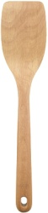
Everything you’re putting into the dip is something you can eat right out of the package. I’m not sure I would want to drink straight vinegar but I could.
STIRRING.
Stir often. Think you're stirring enough? Stir more. Think you're stirring too much? Stir more. Keep the bottom of the pot moving. Use a flat wooden spatula or a like tool and scrape it along the bottom of the pot. This stuff will scorch in a minute.
WARNING.
IF YOU SNIFF THIS SAUCE, YOU'RE GOING TO COUGH. PERFECTLY NORMAL. IF YOU'RE DOING A TASTE TEST, DON'T BREATHE OR YOU'RE GONNA BE WEARING THE DIP.
TASTE TEST.
Now add ingredients to taste.
Take a small portion and put it into a bowl. Add a pinch of sugar or a drop or two of vinegar or whatever you think will make it taste better. Stir it up and see how it tastes. Remember what you put in.
Not sweet enough? Add a bit more sugar or barbeque sauce.
Not tangy enough? White vinegar.
More heat? Hot sauce.
More ketchup will soften a too tangy dip but make it taste more like tomatoes.
More barbeque sauce will soften a too tangy dip AND sweeten it up.
Once you have your sample tasting just right, add those same ingredients to your main pot.
If you cannot get your sample right. Toss it and get another sample and start over.
I'm not telling you to put your bad sample back into the pot...I would never do that (wink). This stuff's expensive. You make the call.
WARNING.
A little can go a long way.
IT'S EASY TO PUT INGREDIENTS IN; IT'S HARD TO GET THEM OUT.
But don't be afraid to add stuff. The bigger the batch the more additional ingredients you may have to add. A tablespoon of vinegar in a one chicken batch will have a great effect on the sauce. That same tablespoon in a 28 chicken batch will have little to no effect.
FINISHING UP.
After everything is well incorporated turn the heat down to low to low-medium and let it cook for 10-15 minutes. Stir occasionally.
Or you can let it sit for a couple of hours on a cold stove. When you're ready to use it, heat it up and get to cooking the meat.
USING THE DIP.
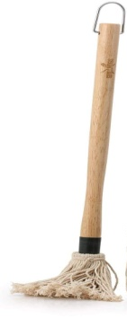
When you're cooking the meat, put the dip on it about 10-15 minutes before the meat is done. Keep an eye on the meat so it doesn’t burn. It may turn a little black in spots – that’s called flavor. Just don’t burn it.
Apply the dip liberally - remember, you made extra. I usually use an applicator that looks like a little mop. It holds a lot of sauce and it looks cool. But use what you want. Turn the meat every 2-3 minutes. When you're finished cooking the chicken/pork put the meat into a metal pot and pour a liberal amount of dip over the meat. Put a lid on it and let it set for 5-10 minutes.
You’re chicken should look something like this. Notice there are a couple of black spots. This chicken was reverse spatchcocked. I cut through the breastbone rather than taking out the backbone. A reverse spatchcock is tougher to do right because you’re cutting thru the breastbone. Look on You Tube to learn how to spatchcock a chicken.
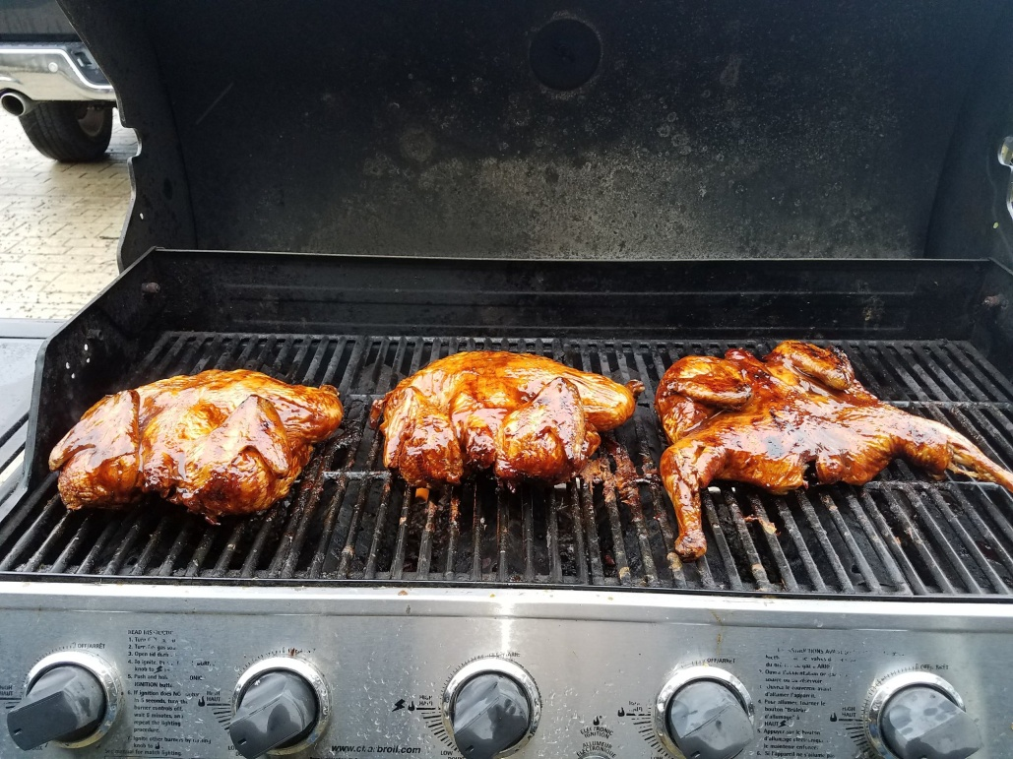

Ingredients and Shopping List
# Chickens | Measure Type | 1 | 2 | 3 | 4 | 5 | Qty Req'd | Got It! | Buy It
White Vinegar | Cup | 5/8 | 1 1/8 | 1 6/8 | 2 2/8 | 2 7/8
Worcestershire Sauce, Lea & Perrins | Cup | 5/8 | 1 1/8 | 1 6/8 | 2 2/8 | 2 7/8
Ketchup, Heinz | Ounce | 1 3/8 | 2 7/8 | 4 2/8 | 5 6/8 | 7 1/8
Lemon Juice | Ounce | 6/8 | 1 3/8 | 2 1/8 | 2 7/8 | 3 5/8
Red Hot Sauce, Franks | Ounce | 3/8 | 7/8 | 1 2/8 | 1 6/8 | 2 1/8
Pepper | Ounce | 1/8 | 3/8 | 4/8 | 6/8 | 7/8
Salt | Ounce | 6/8 | 1 3/8 | 2 1/8 | 2 7/8 | 3 5/8
Crisco | Cup | 2/8 | 5/8 | 7/8 | 1 1/8 | 1 3/8
Brown Sugar | Cup | 1/8 | 1/8 | 1/8 | 1/8 | 1/8
Barbeque Sauce, Kraft Original | Ounce | 2 4/8 | 5 | 7 4/8 | 10 | 12 4/8
# Chickens | Measure Type | 6 | 7 | 8 | 9 | 10 | Qty Req'd | Got It! | Buy It
White Vinegar | Cup | 3 3/8 | 4 | 4 5/8 | 5 1/8 | 5 6/8
Worcestershire Sauce, Lea & Perrins | Cup | 3 3/8 | 4 | 4 5/8 | 5 1/8 | 5 6/8
Ketchup, Heinz | Ounce | 8 5/8 | 10 | 11 3/8 | 12 7/8 | 14 2/8
Lemon Juice | Ounce | 4 2/8 | 5 | 5 6/8 | 6 3/8 | 7 1/8
Red Hot Sauce, Franks | Ounce | 2 5/8 | 3 | 3 3/8 | 3 7/8 | 4 2/8
Pepper | Ounce | 1 1/8 | 1 2/8 | 1 3/8 | 1 5/8 | 1 6/8
Salt | Ounce | 4 2/8 | 5 | 5 6/8 | 6 3/8 | 7 1/8
Crisco | Cup | 1 6/8 | 2 | 2 2/8 | 2 5/8 | 2 7/8
Brown Sugar | Cup | 2/8 | 2/8 | 2/8 | 3/8 | 3/8
Barbeque Sauce, Kraft Original | Ounce | 15 | 17 4/8 | 20 | 22 4/8 | 25

# Chickens | Measure Type | 11 | 12 | 13 | 14 | 18 | Qty Req'd | Got It! | Buy It
White Vinegar | Cup | 6 2/8 | 6 7/8 | 7 3/8 | 8 | 10 2/8
Worcestershire Sauce, Lea & Perrins | Cup | 6 2/8 | 6 7/8 | 7 3/8 | 8 | 10 2/8
Ketchup, Heinz | Ounce | 15 6/8 | 17 1/8 | 18 5/8 | 20 | 25 6/8
Lemon Juice | Ounce | 7 7/8 | 8 5/8 | 9 2/8 | 10 | 12 7/8
Red Hot Sauce, Franks | Ounce | 4 6/8 | 5 1/8 | 5 5/8 | 6 | 7 6/8
Pepper | Ounce | 2 | 2 1/8 | 2 3/8 | 2 4/8 | 3 2/8
Salt | Ounce | 7 7/8 | 8 5/8 | 9 2/8 | 10 | 12 7/8
Crisco | Cup | 3 1/8 | 3 3/8 | 3 6/8 | 4 | 5 1/8
Brown Sugar | Cup | 3/8 | 3/8 | 4/8 | 4/8 | 5/8
Barbeque Sauce, Kraft Original | Ounce | 27 4/8 | 30 | 32 4/8 | 35 | 45
# Chickens | Measure Type | 20 | 24 | 28 |  |  | Qty Req'd | Got It! | Buy It
White Vinegar | Cup | 11 3/8 | 13 6/8 | 16
Worcestershire Sauce, Lea & Perrins | Cup | 11 3/8 | 13 6/8 | 16
Ketchup, Heinz | Ounce | 28 5/8 | 34 2/8 | 40
Lemon Juice | Ounce | 14 2/8 | 17 1/8 | 20
Red Hot Sauce, Franks | Ounce | 8 5/8 | 10 2/8 | 12
Pepper | Ounce | 3 5/8 | 4 2/8 | 5
Salt | Ounce | 14 2/8 | 17 1/8 | 20
Crisco | Cup | 5 6/8 | 6 7/8 | 8
Brown Sugar | Cup | 6/8 | 7/8 | 1
Barbeque Sauce, Kraft Original | Ounce | 50 | 60 | 70

Conversion Table
Dry Measure
3 tsp | 1 Tbs | 1/2 Oz
2 Tbs | 1/8 C | 1 Fl Oz
4 Tbs | 1/4 C | 2 Fl Oz
5 1/3 Tbs | 1/3 C | 2.6 Fl Oz
8 Tbs | 1/2 C | 4 Oz
12 Tbs | 3/4 C | 6 Oz
32 Tbs | 2 C | 16 Oz
64 Tbs | 4 C | 32 Oz
Liquid measures
1/8 C | 1 Fl Oz
2/8 C | 2 Fl Oz
1/3 C | 2.6 Fl Oz
4/8 C | 4 Fl Oz
5/8 C | 5 Fl Oz
3/4 C | 6 Fl Oz
7/8 C | 7 Fl Oz
1 C | 8 Fl Oz | 1/2 Pt
2 C | 16 Fl Oz | 1 Pt
4 C | 32 Fl Oz | 1 Qt
2 Pt | 32 Fl Oz | 1 Qt
4 Qt | 128 Fl Oz | 1 Gl
tsp – Teaspoon
Tbs – Tablespoon
C – Cup
Oz – Ounces
Fl Oz – Fluid Ounces
Pt - Pint
Qt – Quart
Gl - Gallon

